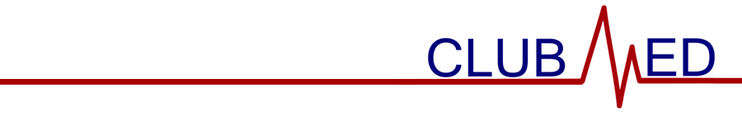

November 15, 2023

General Membership Meeting Minutes

Attendance (members sign-in using Google Form)

Meeting called to order at 9:00 am by Sharon Loyola.

Members in Attendance (attendance sheet on file)

Guests in Attendance

None.

Reading and Approval of Minutes

Minutes were read by Selena Liu. With no changes offered by members, the minutes were approved via unanimous consent.

Treasurer’s Report—Current balance is $6946.44. Expenditures total $0.00. Revenue/Income total $0.00.

Special Reports

CTSO—Reminder that first round of testing begins February; those interested should begin studying.

Community Outreach—Introduction to guest speaker, Stephanie Friedman, Pharm. D.

Apparel—None.

Old Business

State Officer Election interest form.

New Business

None.

- Program/Activity
  - Making Thanksgiving posters.
  - Creating gratitude cards for teachers.

- Announcements
  - WAHOSA interest form due 11/15

- It was moved by Tanvi Dua and seconded by Nicolas Horal to adjourn the meeting at 9:47 am. The motion passed by majority vote.

