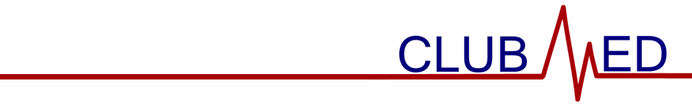

November 29, 2023

General Membership Meeting Minutes

Attendance (members sign-in using Google Form)

Meeting called to order at 9:00 am by Adi Arora.

Members in Attendance (attendance sheet on file)

Guests in Attendance

Stephanie Friedman, Pharm. D.

Reading and Approval of Minutes

Minutes were read by Selena Liu. With no changes offered by members, the minutes were approved via unanimous consent.

Treasurer’s Report—Current balance is $7877.44. Expenditures total $0.00. Revenue/Income total $931.00 from club dues.

Special Reports

CTSO—Members interested in competing at SLC should decide their three events while paying attention to the block schedule.

Community Outreach—Introduced AMR Diversity Scholarship.

Apparel—Submitting apparel order forms today.

Old Business

None.

New Business

None.

- Program/Activity
  - Pharm. D guest speaker presentation.

- Announcements
  - WAHOSA state officer elections are next week.

- It was moved by Lucas Knapp and seconded by Sophia Miele to adjourn the meeting at 10:00 am. The motion passed by majority vote.

