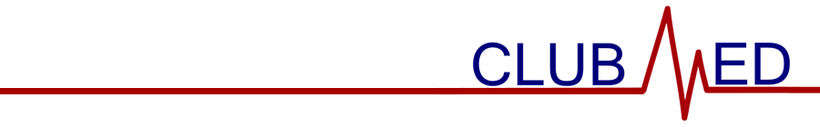

November 8, 2023

General Membership Meeting Minutes

Attendance (members sign-in using Google Form)

Meeting called to order at 9:00 am by Adi Arora.

Members in Attendance (attendance sheet on file)

Guests in Attendance

None.

Reading and Approval of Minutes

Minutes were read by Selena Liu. With no changes offered by members, the minutes were approved via unanimous consent.

Treasurer’s Report—Current balance is $6946.44. Expenditures total $0.00. Revenue/Income total $0.00.

Special Reports

CTSO—If interested in competing at HOSA, should start studying now.

Community Outreach—None.

Apparel—Apparel order form due November 12

Old Business

None.

New Business

None.

- Program/Activity
  - WAHOSA State Office election interest form.
  - Paper patients activity.

- Announcements
  - Sign up to bring food at the Thanksgiving meeting next week.
  - Fill out WAHOSA officer election form if interested
  - Fill out apparel order form by November 12

- It was moved by Nicos Horal and seconded by Preston Miele to adjourn the meeting at 9:51 am. The motion passed by majority vote.

